**TDD**

Test driven development - it is primarily used for unit testing by the development team. It is not a methodology like waterfall or Agile that talks overall (общий) software development cycle, but **it's more of programming style or practice** that talks about how to write the code in iterations (iterations - means during software development iteration).

В целом это когда сначала пишется тест, а потом столько кода (не больше/не меньше) чтобы тест был пройден успешно - ВСЁ!

There are mainly three steps in TDD: **Test, Code, Refuctor**.

1)- The developer would first write an unit test that would describe the functionality to be developed. The test will execute and it will fail as expected.

2) - The developer would then write just enough code to make the test pass.

3) - The developer than would refactor the code, to remove any code duplication or any inconsistency (непоследовательности) in the code. 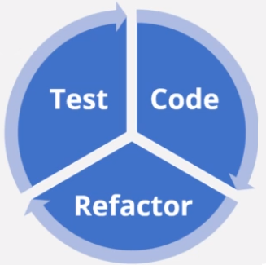

Then the same process is repeated.

This way the developer keeps accumulating unit tests that form the safety net (подстраховку) for the code quality. This practice helps developers to identify the defects (bags) in the developers phase itself. That can reduce the amount of defects that would escape to the later phases of software development, where it can become very costly to fix them. Overall software quality increases because now any change in the code may fail the unit test, and the defects will be caught during development (code phase) itself. In the end, this helps reduce the overall cost at the expense of a slightly delayed development cycle.